Task 1

import java.util.Scanner;  
class item {  
 public String ItemName;  
 public int ItemId;  
 private Float Price;  
 private int Stock;  
 public void setPrice(Float price) {  
 Price = price;  
 }  
 public Float getPrice() {  
 return Price;  
 }  
 public int getStock() {  
 return Stock;  
 }  
 public void setStock(int stock) {  
 Stock = stock;  
 }  
}  
public class  
Main {  
 public static void main(String[] args) {  
 Scanner get = new Scanner(System.*in*);  
  
 System.*out*.println("Hello world!");  
 item Pen = new item();  
 item Book = new item();  
 // Setting Price  
 Pen.setPrice(20.50f);  
 Book.setPrice(500f);  
 //Setting Stock  
 Pen.setStock(50);  
 Book.setStock(300);  
 // Taking Order  
 int choice,pens=0,books=0;  
 char purchase;  
 do {  
 System.*out*.println("What do you want to purchase");  
 System.*out*.println("1 PEN Price = " +Pen.getPrice() );  
 System.*out*.println("2 Book Price = " + Book.getPrice());  
 choice = get.nextInt();  
  
 switch (choice){  
 case 1 :  
 System.*out*.println("how many Pens do you want to purchase");  
 pens = get.nextInt();  
 break;  
 case 2:  
 System.*out*.println("How may Books do you want to purchase");  
 books = get.nextInt();  
 break;  
 }  
 System.*out*.println("Do you want to continue Purchase yes 'y' No 'N'");  
 purchase = get.next().charAt(0);  
 }while (purchase !='N');  
 System.*out*.println("You are here");  
 float total=0;  
 total = (pens \* Pen.getPrice()) + (books \* Book.getPrice()) ;  
 System.*out*.println("Your total bill is = "+total);  
 }  
}

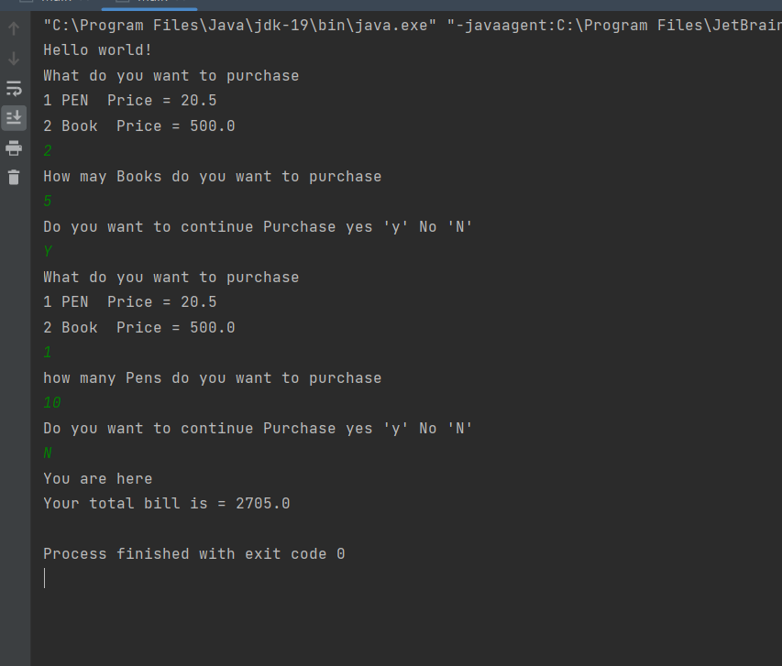

Task 2

class book{  
 public String title;  
 public String author;  
 public double price;  
 public book(String title,String author,double price){  
 this.title = title;  
 this.author = author;  
 this.price = price;  
 }  
 public void setTitle(String title) {  
 this.title = title;  
 }  
 public void setAuthor(String author) {  
 this.author = author;  
 }  
 public void setPrice(double price) {  
 this.price = price;  
 }  
 public String getAuthor() {  
 return author;  
 }  
 public String getTitle() {  
 return title;  
 }  
 public String toString(){  
 return "Title of Book "+title+"\nName of Author"+author+"\nPrice of Book"+price;  
 }  
}  
public class BookDemo {  
 public static void main(String[] args) {  
 book b1 = new book("Great Expectations","Charles Dickens",79.75);  
 System.*out*.println(b1.toString());  
 }  
}

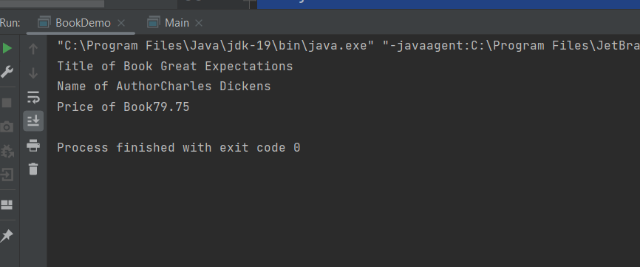

Q3

import java.util.Scanner;  
class Employee{  
 public String FirstName;  
 public String LastName;  
 public double Salary;  
 public Employee(String FirstName,String LastName,double salary){  
 if (Salary<0){  
 salary=0.0;  
 }  
 this.FirstName = FirstName;  
 this.LastName = LastName;  
 this.Salary = salary;  
 }  
 public String Display(){  
 // Salary = Salary+(Salary\*.10);  
 return "First Name "+FirstName+"\nLast Name "+LastName+"\nSalary is "+Salary;  
 }  
}  
public class Main {  
 public static void main(String[] args){  
 System.*out*.println("Welcome to JAVA");  
 Employee E1 = new Employee("Partham","Chawla",2000);  
 Employee E2 = new Employee("Hello","World",500);  
 System.*out*.println(E1.Display());  
 System.*out*.println(E2.Display());  
 }  
}

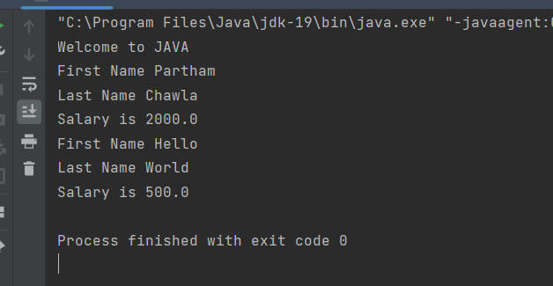

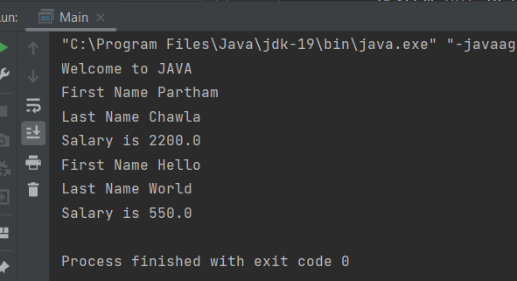

Q4

class Student{  
 public int Age;  
 public String Name;  
 public String Course;  
 public Student(int Age,String Name,String Course){  
 this.Age = Age;  
 this.Name = Name;  
 this.Course = Course;  
 }  
 public String Display(){  
 return "My Name is "+Name+"\nI am "+Age+" year old\nMy course is " +Course;  
 }  
}  
public class Main {  
 public static void main(String[] args){  
 System.*out*.println("Welcome to JAVA");  
 Student me = new Student(19,"Partham","OOP IN JAVA");  
 System.*out*.println(me.Display());  
 }  
}

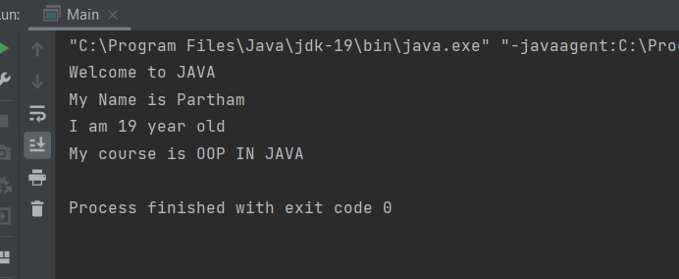

Q5import java.util.Scanner;  
class Employee{  
 public int employeeNO;  
 public String employeeName;  
 public String employeePhNo;  
 private int Salary;  
 public Employee() {  
 }  
 public int getSalary() {  
 return Salary;  
 }  
 public void setSalary(int salary) {  
 Salary = salary;  
 }  
 public String Display(){  
 return "Employee No is "+employeeNO+"\nEmployee Name is "+employeeName+"\nEmployee Ph No is "+employeePhNo+"\nEmployee Salary is "+getSalary();  
 }  
}  
public class Main {  
 public static void main(String[] args){  
 Scanner get = new Scanner(System.*in*);  
 System.*out*.println("Welcome to JAVA");  
 int emp;  
 System.*out*.println("Enter the number of Employees");  
 emp = get.nextInt();  
 // Array of objects  
 Employee[] E = new Employee[emp];  
 int i;  
 for (i=0;i<emp;i++){  
 E[i]=new Employee();  
 System.*out*.println("Enter the Employee Number");  
 E[i].employeeNO = get.nextInt();  
 System.*out*.println("Enter Employee Name");  
 E[i].employeeName = get.next();  
 System.*out*.println("Enter phone number");  
 E[i].employeePhNo = get.next();  
 System.*out*.println("Enter the Salary");  
 E[i].setSalary(get.nextInt());  
 System.*out*.println("Enter the DATA for Other Employee ");  
 }  
 for (i=0;i<emp;i++){  
 System.*out*.println(E[i].Display());  
 }  
 int high =0;  
 for (i=0;i<emp;i++){  
 if(E[i].getSalary()>high){  
 high=E[i].getSalary();  
 }  
 }  
 System.*out*.println("This is the Heighst Salary"+high);  
 }  
}

